|  |  |  |  |
| --- | --- | --- | --- |
| NAME: | Sarcol, Joshua | DATE: | 09/17/2023 |

PRACTICE EXERCISE # 3.1

# LE3.11 Weekly Pay.

Create a program that asks for user’s yearly pay and displays his weekly pay.

## Flowchart: Weekly Pay

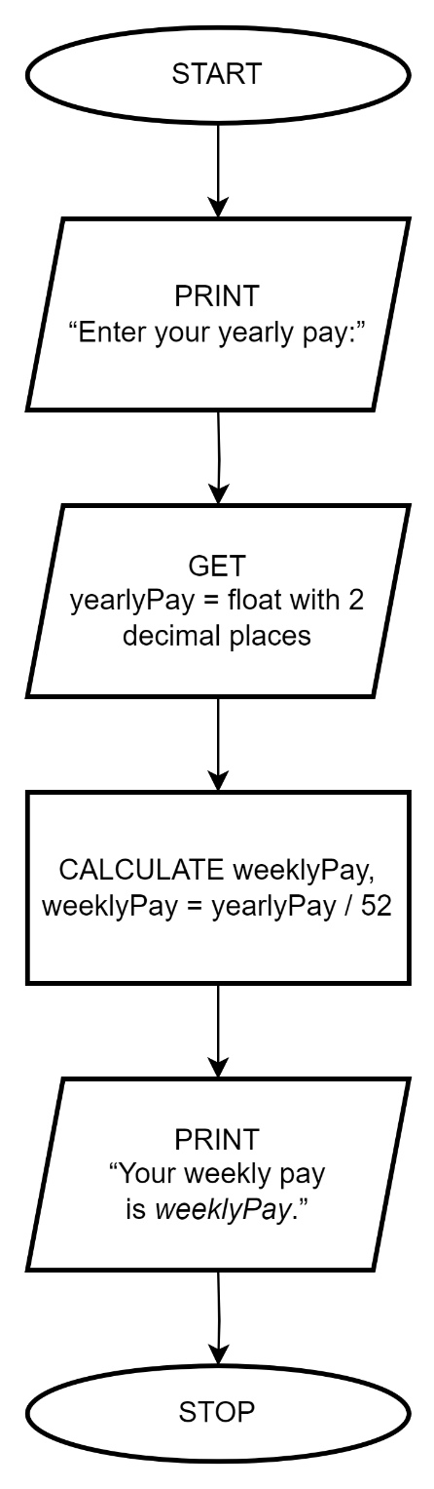

## Pseudocode: Weekly Pay

|  |  |
| --- | --- |
| START | |
| 1 | PRINT “Enter your yearly pay:” |
| 2 | GET yearlyPay = float with 2 decimal places |
| 3 | CALCULATE weeklyPay, weeklyPay = yearlyPay / 52 |
| 4 | PRINT “Your weekly pay is *weeklyPay*.” |
| STOP | |

## C Code: Weekly Pay

#include <stdio.h>

int main ()

{

float yearlyPay;

printf("Enter your yearly pay: ");

scanf("%f", &yearlyPay);

float weeklyPay = yearlyPay/52;

printf("Your weekly pay is %.2f", weeklyPay);

return 0;

}

# LE3.12 Add Digits.

Create a program that extracts and adds the two least significant digits of an integer.

Sample/Test Output

Enter a number : 12345

Sum : 4 + 5 = 9

===========================

Enter a number : 789

Sum : 8 + 9 = 17

## Flowchart: Add digits

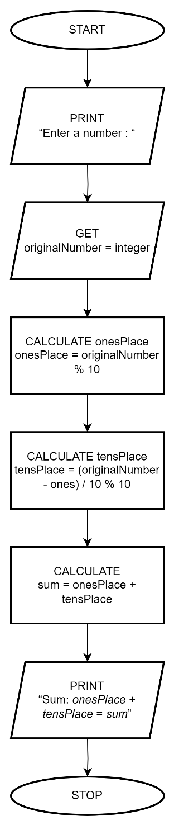

## Pseudocode: Add digits

|  |  |
| --- | --- |
| START | |
| 1 | PRINT “Enter a number : “ |
| 2 | GET originalNumber = integer |
| 3 | CALCULATE onesPlace, onesPlace = originalNumber % 10 |
| 4 | CALCULATE tensPlace, tensPlace = (originalNumber - onesPlace) / 10 % 10 |
| 5 | CALCULATE sum = onesPlace + tensPlace |
| 6 | PRINT “Sum : *tensPlace* + *onesPlace* = *sum*” |
| STOP | |

## C Code: Add digits

#include <stdio.h>

int main ()

{

int originalNumber;

printf("Enter a number\t: ");

scanf("%d", &originalNumber);

int onesPlace = originalNumber % 10;

int tensPlace = (originalNumber - onesPlace) / 10 % 10;

int sum = onesPlace + tensPlace;

printf("Sum\t\t: %d + %d = %d", tensPlace, onesPlace, sum);

return 0;

}

# LE3.13 Tuition Fee.

Create a program that prints the tuition for 2 semesters at ABC College. ABC charges PHP 450 for registration, plus PHP 450 per unit and a penalty of PHP 2,260 for each 12 units or fraction of 12.

Sample/Test Output

1st Semester Number of Units: 12

2nd Semester Number of Units: 25

1st Semester Tuition Fee : 8110.00

2nd Semester Tuition Fee : 16408.33

Total Tuition Fee : 24518.33

## Flowchart: Tuition Fee

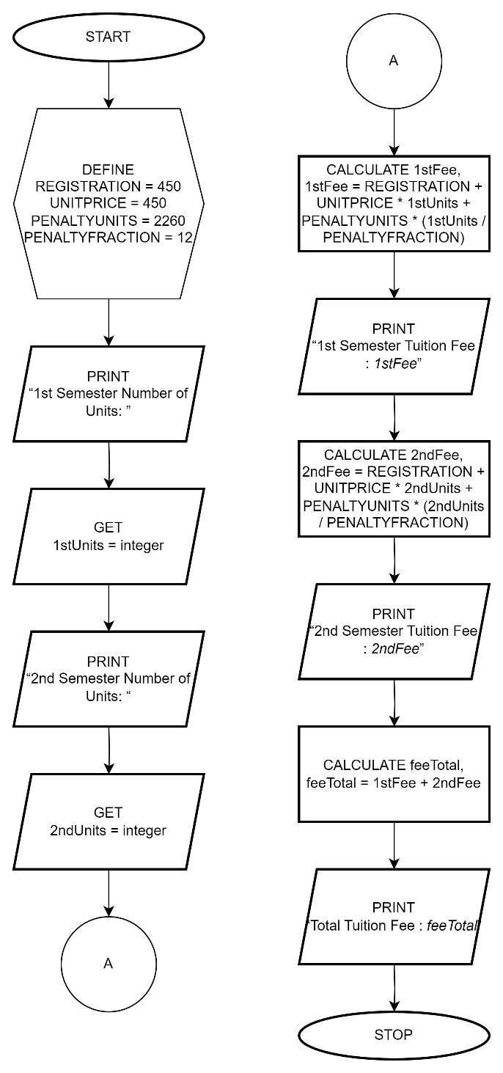

## Pseudocode: Tuition Fee

|  |  |
| --- | --- |
| START | |
| 1 | DEFINE REGISTRATION = 450 |
| 2 | DEFINE UNITPRICE = 450 |
| 3 | DEFINE PENALTYUNITS = 2260 |
| 4 | DEFINE PENALTYFRACTION = 12 |
| 5 | PRINT “1st Semester Number of Units: ” |
| 6 | GET 1stUnits = number |
| 7 | PRINT “2nd Semester Number of Units: “ |
| 8 | GET 2ndUnits = number |
| 9 | CALCULATE 1stFee, 1stFee = REGISTRATION + UNITPRICE * 1stUnits + PENALTYUNITS * (1stUnits / PENALTYFRACTION) |
| 10 | PRINT “1st Semester Tuition Fee : *1stFee*” |
| 11 | CALCULATE 2ndFee, 2ndFee = REGISTRATION + UNITPRICE * 2ndUnits + PENALTYUNITS * (2ndUnits / PENALTYFRACTION) |
| 12 | PRINT “2nd Semester Tuition Fee : *2ndFee*” |
| 13 | CALCULATE feeTotal, feeTotal = 1stFee + 2ndFee |
| 14 | PRINT “Total Tuition Fee : *feeTotal*” |
| STOP | |

## C Code: Tuition Fee

#define REGISTRATION 450

#define UNITPRICE 450

#define PENALTYUNITS 2260

#define PENALTYFRACTION 12

#include <stdio.h>

int main ()

{

float firstUnits, secondUnits;

printf("1st Semester Number of Units\t: ");

scanf("%f", &firstUnits);

printf("2nd Semester Number of Units\t: ");

scanf("%f", &secondUnits);

float firstFee = REGISTRATION + UNITPRICE * firstUnits + PENALTYUNITS * (firstUnits / PENALTYFRACTION);

printf("1st Semester Tuition Fee\t: %7.2f\n", firstFee);

float secondFee = REGISTRATION + UNITPRICE * secondUnits + PENALTYUNITS * (secondUnits / PENALTYFRACTION);

printf("2nd Semester Tuition Fee\t: %7.2f\n", secondFee);

float feeTotal = firstFee + secondFee;

printf("Total Tuition Fee\t\t: %7.2f", feeTotal);

return 0;

}